**Alert 2011-2013 incandescence calibrations**

The three SP2a used at Alert were calibrated using Aquadag (Acheson Industries) and as an external rBC standard. Generated Aquadag particles were size selected with a differential mobility analyzer (DMA) and the mobility diameters were used to derive the rBC mass using the parameterization of Gysel and colleagues (Gysel et al., 2011). Recent studies have shown that the SP2 is more sensitive to Aquadag than it is to other types of black carbon, and if the Aquadag calibration curves are used directly it can lead to underestimation of ambient rBC mass (Laborde et al., 2012; Moteki and Kondo, 2010). To account for this, the Aquadag calibration curves were scaled by a factor of 0.70 ± 0.05. This factor was derived from Figure 5 in Laborde et al. (Laborde et al., 2012) which shows the relative sensitivity of the SP2 to Aquadag as well as to rBC from denuded ambient particles and from diesel and wood smoke.

SP2#58 is an 8-channel instrument with both high and low gain channels for measuring incandescence. The high gain channel is best suited for measuring signals from smaller particles while the low gain channel is better suited to larger particles. It was used from 27 Sept 2013 through 31 Dec 2013. Calibrations were carried out on 6 Nov 2012, 30 Aug 2014, 11 April 2015 and 1 Dec 2015. Since there was no trend in the calibrations, all of these were combined and fit with a second order polynomial to produce the curves shown in Figure 1. When using the high and low gain channels to arrive at the mass of a particle, the following procedure was used. Masses from 0.33-1.8fg were calculated using the high gain channel only (blue shaded region in Figure 1). Masses from 12.8-41fg were calculated using the low gain channel only (yellow shaded region in Figure 1). Masses from 1.8-12.8fg were calculated using the average result from the high and low gain channels (green shaded region in Figure 1). The 1-hour mass concentrations are using particles in the mass detection range of 0.4-41fg (~75-350nm VED at a density of 1.8g/cm3 (Bond and Bergstrom, 2006))

SP2#44 is also an 8-channel instrument and it was used from 27 March 2012 to 22 Sept 2013. It was calibrated on 7 March 2012. In this case both the high and low gain channels were calibrated over the same mass range (Figure 2), so only the high gain channel was used to determine particle masses. The 1-hour mass concentrations are using particles in the mass detection range of 0.4-12.7fg (~75-240nm VED at a density of 1.8g/cm3)

SP2#17 is a 4-channel instrument that was used from 5 March 2011 to 24 March 2012 and calibrated on 6 Dec 2010. Since this instrument does not have a low gain channel, all masses were calculated using the high gain results (Figure 3). The 1-hour mass concentrations are using particles in the mass detection range of 0.4-12.4fg (~75-235nm VED at a density of 1.8g/cm3)

The uncertainty in mass reported here is the combined uncertainty arising from uncertainty in the fit of the calibration curve and from the uncertainty in the Aquadag correction factor. For SP2#58 the mean uncertainty in the 1-hour mass concentration was 19%, for SP2#44 it was 18%, and for SP#17 it was 23%.

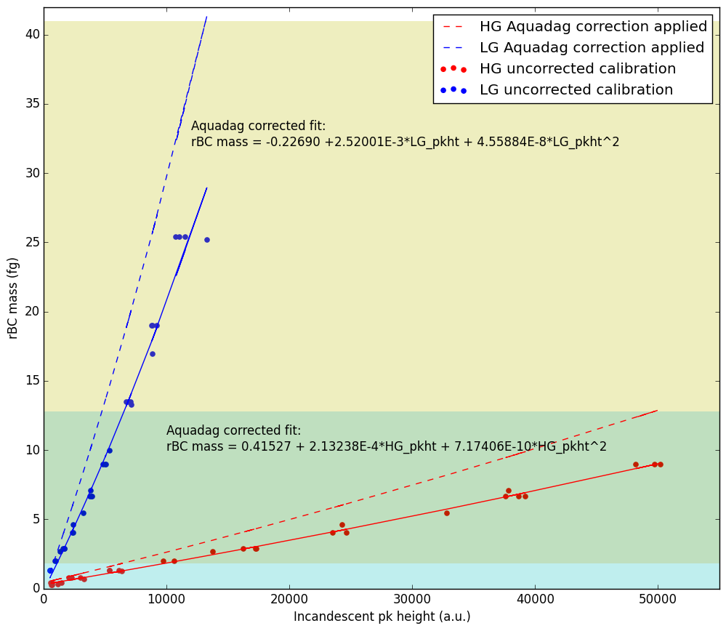

Figure 1 Aquadag calibration for SP2#58 at Alert

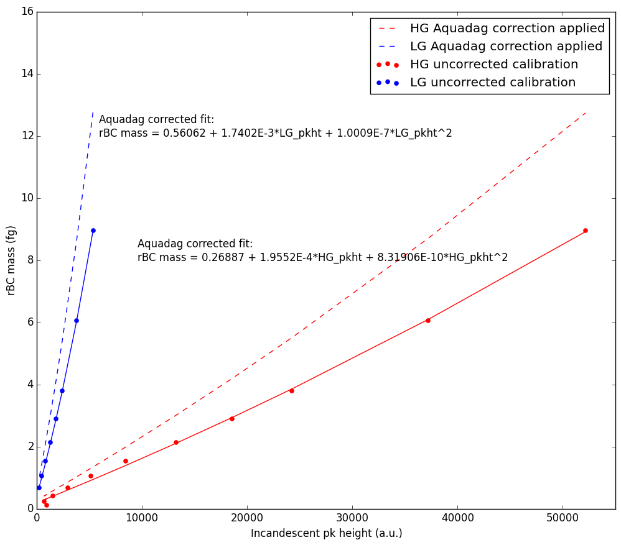

Figure 2 Aquadag calibration for SP2#44 at Alert

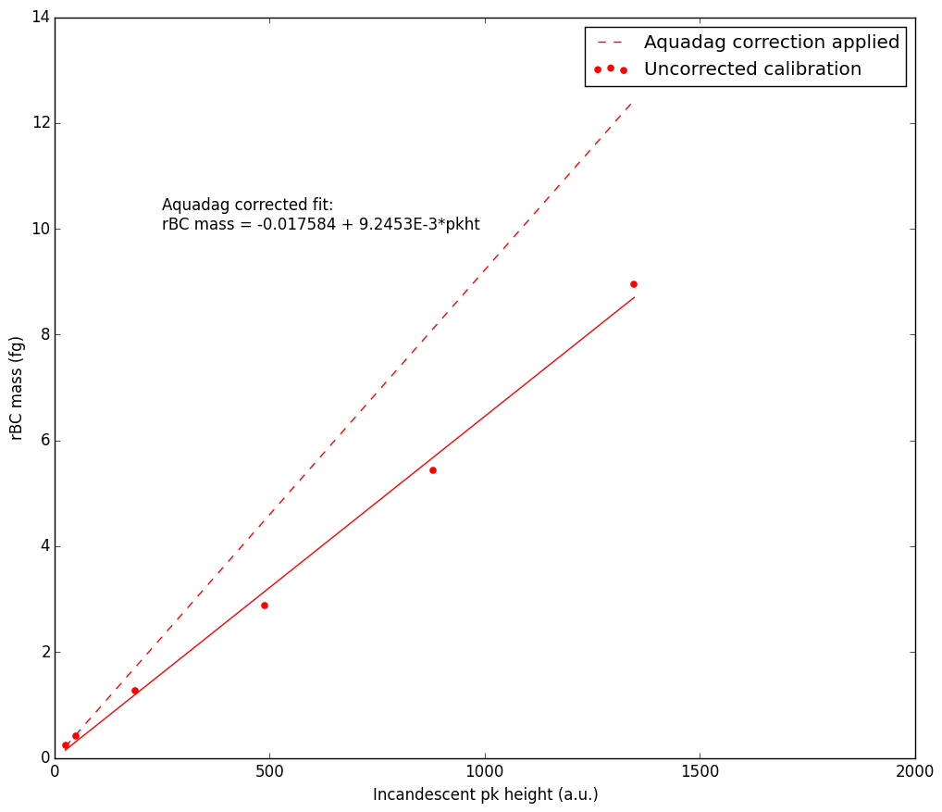

Figure 3 Aquadag calibration for SP2#17 at Alert

**References:**

Bond, T. C. and Bergstrom, R. W.: Light Absorption by Carbonaceous Particles: An Investigative Review, Aerosol Sci. Technol., 40(1), 27–67, doi:10.1080/02786820500421521, 2006.

Gysel, M., Laborde, M., Olfert, J. S., Subramanian, R. and Gröhn, a. J.: Effective density of Aquadag and fullerene soot black carbon reference materials used for SP2 calibration, Atmos. Meas. Tech., 4(12), 2851–2858, doi:10.5194/amt-4-2851-2011, 2011.

Laborde, M., Mertes, P., Zieger, P., Dommen, J., Baltensperger, U. and Gysel, M.: Sensitivity of the Single Particle Soot Photometer to different black carbon types, Atmos. Meas. Tech., 5(5), 1031–1043, doi:10.5194/amt-5-1031-2012, 2012.

Moteki, N. and Kondo, Y.: Dependence of Laser-Induced Incandescence on Physical Properties of Black Carbon Aerosols: Measurements and Theoretical Interpretation, Aerosol Sci. Technol., 44(8), 663–675, doi:10.1080/02786826.2010.484450, 2010.